This document describes the setup of the Oracleprod server which is used to host Unilab and Interspec (and report manager).

It will describe the specific Windows setup. The setup of the Oracle database and it’s interfaces is described in a different document.

Setup is started by a clean install of Windows. In this case: Windows 2012 R2.

There are three disk partitions:

* C:\ Windows + software
* D:\ Databases + input dir
* E:\ Backups

Attached to this document card you will find 3 text documents describing the exact folder structure.

Oracle

De sources om Oracle 11.2.0.4 te installeren staan in: C:\install\Oracle

Datum & Tijd

Datum en tijd van de server moeten op Amerikaans formaat staan ingesteld.

Services

There are a two specific services that need to be added to run and start automatically:

* ToPibs Sends an xml file to Pibs when via a CoA a raw material may be released
* Oracle services

ToPibs service may be started by executing: C:\services\Install ToPibs shortcut. Which will start ToPibs.exe (in the same directory) as a service.  
ToPibs needs E:\log\ToPibs to be able to write a logfile.  
Files that need to be send to Pibs are copied to: D:\unilink\out

ToPibs includes an ftp server to send messages to Pibs.

FTP

There also needs to be an ftp server that is able to accept unilink files from Pibs (COP test requests).

* username enschede\ftp_pibs
* wachtwoord @p0ll0vr

The incoming files should be written to:

D:\unilink\in

This document describes in detail how to setup an ftp server on Windows 2012 R2:

<https://vpsie.com/knowledge-base/how-to-setup-ftp-server-users-on-windows-2012-r2/>

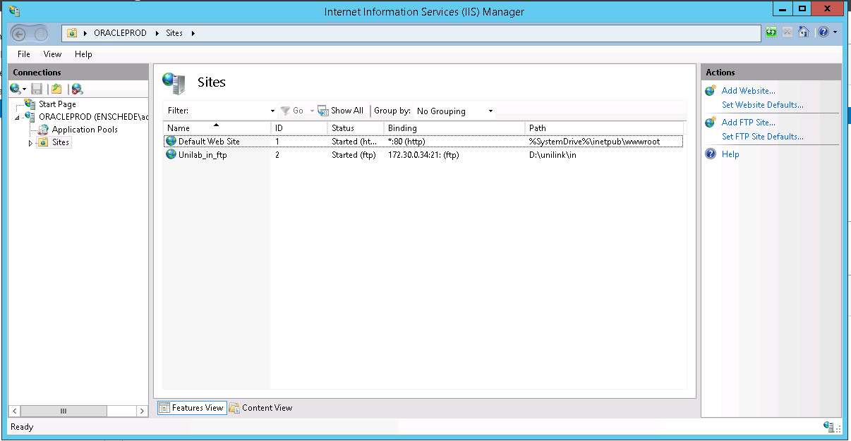

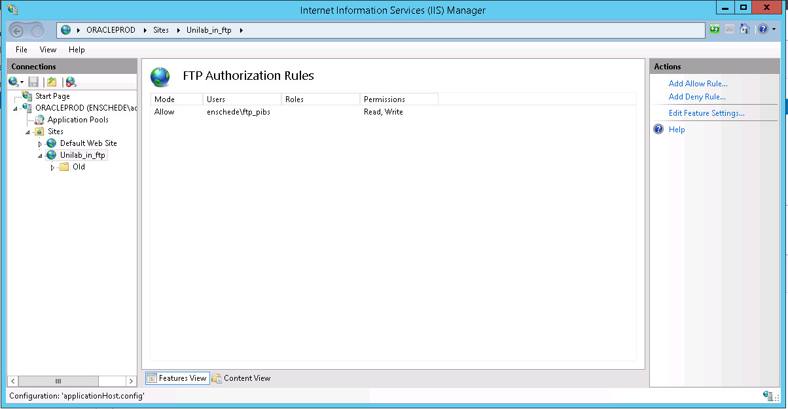

Fileshares

Three fileshares are defined:

* CatiaExport$ D:\Export\Catia
* fea D:\interface\fea
* unilink D:\unilink

Security:

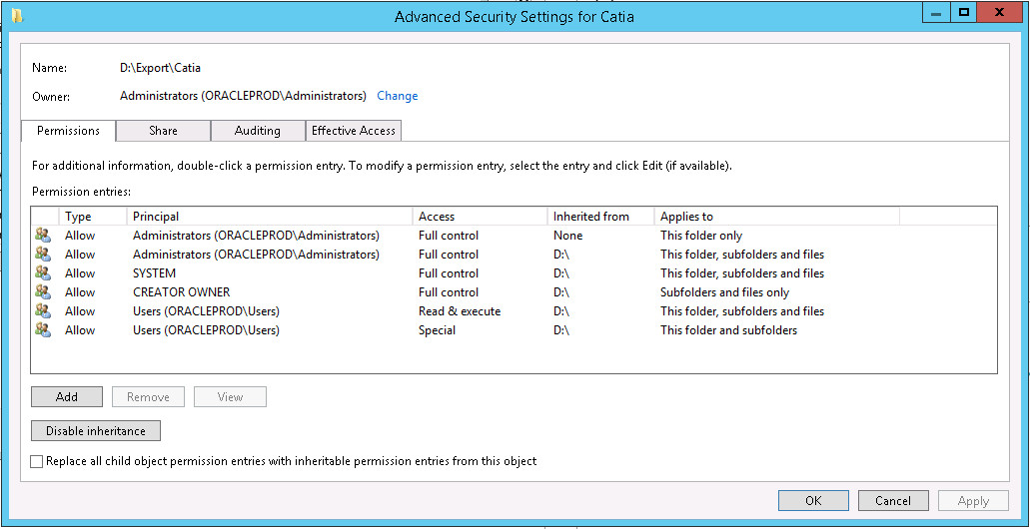

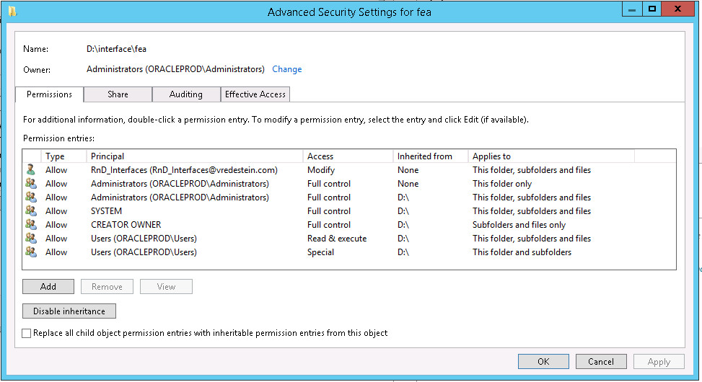

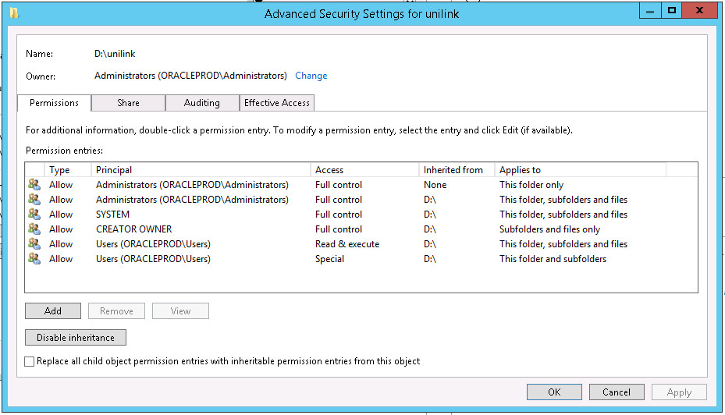

#### Backups

There are a number of batch files in: E:\Backup

They can be used to make either incremental or full backups from the databases using: rman.

The databases to backup are:

* IS61 Interspec
* U611 Unilab
* REPM Report Manager (BO)

These batch files run as scheduled jobs (using Windows task scheduler).

The below screenshots are an example of how the Interspec backup job is scheduled. The other two batch jobs are scheduled in the same way.

We have 6 backup batchfiles and 1 delete batchfile:

* bck_full_is61.bat Every Friday at 7:00pm
* bck_full_repm.bat Every Friday at 7:50pm
* bck_full_u611.bat Every Friday at 6:00pm
* bck_incr_is61.bat Every day at 8:00pm
* bck_incr_repm.bat Every day at 9:00pm
* bck_incr_u611.bat Every day at 8:30pm
* DeleteLargefiles.bat

The last one is needed to delete the full backup file(s) to make space available for a next backup.

Teunis used to free diskspace just before he started a full backup. We want to try to only delete it after a successful full backup.

“Real” backups are taken every workday at 10:00pm (incremental), every Friday at 10:00pm Full (until approx.. 5:00am on Saturday). On Sunday, full backup is written to tape.

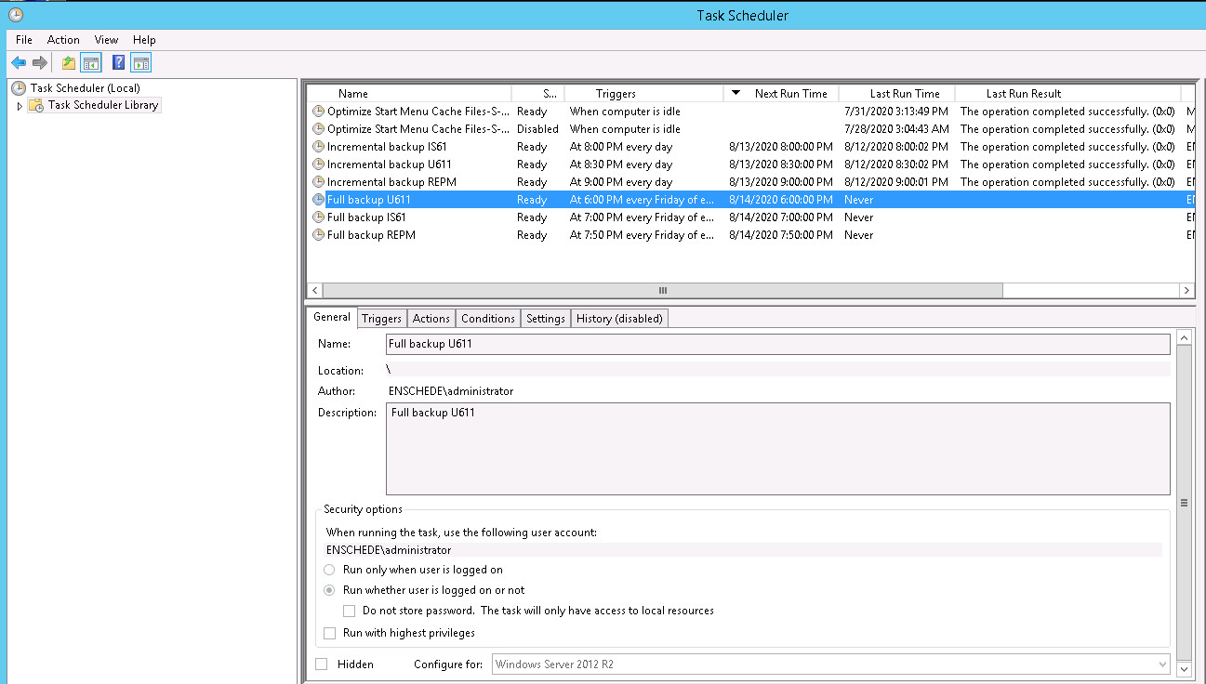

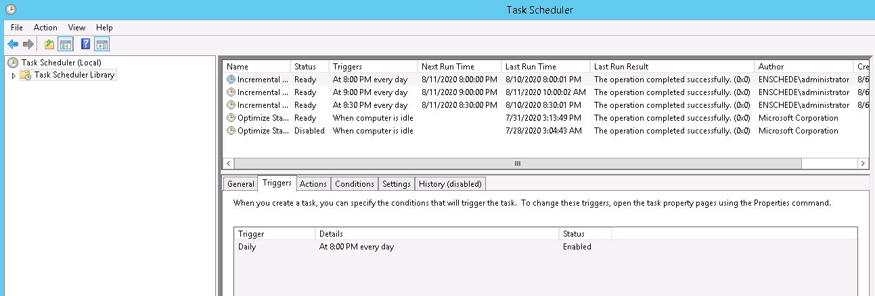

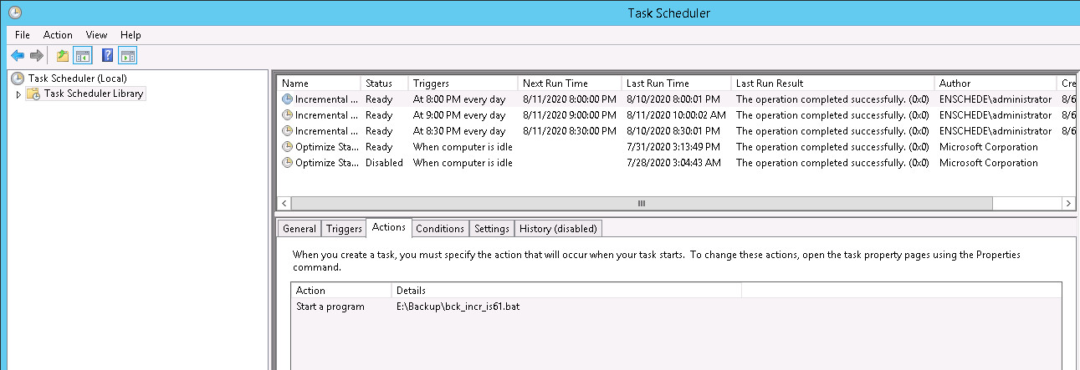

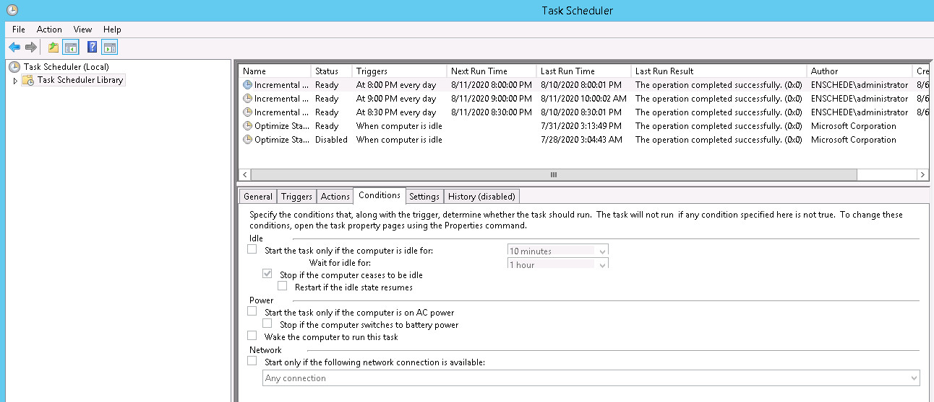

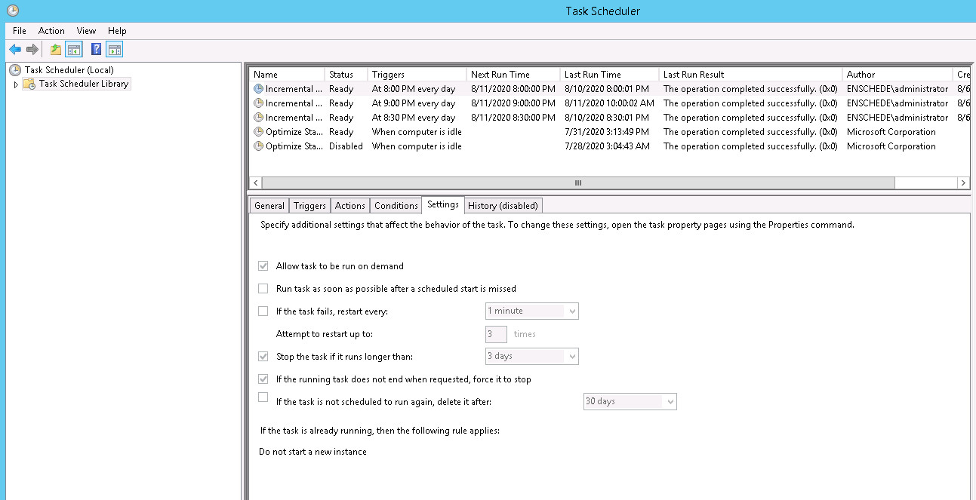

#### Report manager

Let op! Nadat de Oracle databases herstart zijn moet meestal de limsreport_64 server ook een keer ge-reboot worden. Die is dan zijn connectie met de REPM database kwijt.

#### Restartalldbjabs

Na een herstart van de Unilab server moeten we ook zeker weten dat de server is gestart mbv: startalldbjobs vanuit de package: CXAPP.  
Wanneer deze niet gebruikt wordt voor het opstarten kan het resulteren in “numeric or value error” meldingen.